Приложение 1

Etiquette politeness spirit feeling communication skills relations
Particular quality intonation of the voice make a good impression unwritten
rulesRelations good manners social behavior hand gestures

Приложение 2
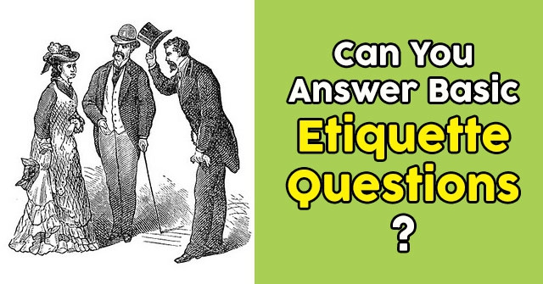

Приложение 3
The Importance of Etiquette

Introduction
Some people argue that etiquette no longer matters, that the rules for good behavior are old-fashioned and out of date. However, good behavior and manners are never out of style. Etiquette, like all other cultural behaviors, evolves to match the times. Without etiquette, members of society would show far too much impatience and disrespect for one another, which would lead to insults, dishonesty, cheating, road rage, fist fights, and a rash of other unfortunate incidents.
Etiquette is merely a set of guidelines for politeness and good manners, the kindnesses with which we should always treat each other. It will always matter!
What Is Etiquette?
Etiquette, the complex network of rules that govern good behavior and our social and business interactions, is always evolving and changing as society changes. It reflects our cultural norms, generally accepted ethical codes, and the rules of various groups we belong to.
It helps us show respect and consideration to others and makes others glad that we are with them. Without proper manners and etiquette, the customs of polite society would soon disappear and we would act more like animals and less like people. Aggressiveness and an "every man for himself" attitude would take the lead.
In earlier times, the rules of etiquette were used for two purposes: to remind people of their own status within society and to reinforce certain restrictions on individuals within that society.
In the Middle Ages and the Renaissance, for instance, etiquette dictated everything from how low a person of inferior rank had to bow to a person of higher rank to how long a man had to spend courting a woman before the two could marry.
Even the way a person mourned was strictly outlined by rules of etiquette until as recently as the Civil War era in the United States. Widows then were expected to dress in "widow's weeds," or completely black clothing and veils, for a full year after the death of a husband.
These types of rules in earlier society were usually determined by the ruling classes because they served the purpose of making them more secure in their roles as the rulers of society. By far, the most strenuously enforced rules of etiquette were tied to how one showed respect for the king and his highest ranking officials, such as dukes and princes. It reinforced their authority.
The rules of etiquette concerning marriage, mourning, and other major events of life largely applied only to the ruling classes or the wealthy. Peasants and workers, as long as they followed the rules of etiquette pertaining to respecting their superiors, were not expected to follow formalized rules of courtship; they tended to base their own "rules" of courtship on good manners and common sense.
Over the centuries, as society has become more democratic, etiquette has become an excellent combination of good manners, common sense, and rules of conduct that reflect cultural norms and the rules of our society as a whole rather than just one distinct group within it. It has less to do with the fashion of the moment or who is in power and more to do with putting others at ease and an ethical code of conduct.
Etiquette in Today's Society
Today's etiquette serves several important functions:
Etiquette provides personal security.
It protects the feelings of others.
·It makes communication clearer.
·It will enhance your status at work.
·It makes good first impressions.

Society and our culture are now changing so fast that it is hard for the rules of etiquette to keep up. As quickly as a book of etiquette is published, a new form of communication is developed or a new style of dating becomes all the rage and someone declares the latest etiquette book "hopelessly outdated." Keep in mind that etiquette is meant to be a guideline, not a set of strict rules carved in stone. Those guidelines are developed using common sense, a sense of fairness, politeness, and above all, consideration for others. If you let consideration for others be your final arbiter, you will be well on your way to being the kind of polite person who understands the rules of etiquette instinctively.

Etiquette Begins at Home
The reason many young people today do not know much about etiquette is because they never learned it at home--parents no longer directly teach children and teenagers etiquette. If you are reading this to learn more about proper manners and how to practice etiquette in public, your best bet is to start practicing it in private. It is difficult to switch on good behavior only when you feel like you "need to." In fact, we really should not be on our best behavior only around people we barely know or want to impress. Our best behavior should be for the people we love: our friends and family.
Therefore, practice the highest standards of etiquette at home. Be sure to be polite and kind toward your spouse, parents, and children, especially your children, so they will learn from example the proper way to treat other people. If they grow up with etiquette ingrained in them, they will find it easier to form lasting relationships, be successful in their jobs, and move through life as the kind of people others enjoy being around.
You also will find that etiquette becomes second nature to you rather than a set of rules, and your own life will be more pleasant. People respond positively to those who are nice to them and who treat them with respect. Proper etiquette guides you in how to do this without "missing something" because you simply were not aware that something you did or did not do might be offensive to the other person.

